Eaton Corporation plc (ETN) Visual Equity Report
ETN visual equity report core generated from the tightened multi-format Veritas workflow.
VERITAS ALERT: ETN closed at $423.92 on 2026-04-24. 20-day / 50-day / 200-day levels are $389.29 / $375.64 / $361.22. Current status: PULLBACK ONLY. Trend quality is strong, but price is pressing highs and current entry quality is poor. Wait for a disciplined pullback or a better-defined reset.

1. Executive Summary
Eaton Corporation plc is a real institutional-quality company in Industrials / Specialty Industrial Machinery, with market capitalization of $164.5B, forward earnings multiple of 27.4, and analyst support that still leans constructive. The name remains worth covering even when the current setup is not clean enough to buy.
At the market level, ETN closed at $423.92, with recent support near $343.53, resistance near $424.50, and a 52-week range of $275.98 to $432.34. Consensus target sits at $412.95, implying -2.6% from the current price.
The right current interpretation is PULLBACK ONLY. Trend quality is strong, but price is pressing highs and current entry quality is poor. Wait for a disciplined pullback or a better-defined reset. This report therefore emphasizes a clean company snapshot, visual price context, real annual financial history, and a simple action view rather than padding the output with generic commentary.

2. Company Snapshot
Metric | Value
Ticker | ETN (NYSE)
Full name | Eaton Corporation plc
Sector / industry | Industrials / Specialty Industrial Machinery
Market cap | $164.5B
Enterprise value | $174.4B
Employees | 97,303
Dividend yield | 1.0%
Analyst rating | 1.7 - Buy
Consensus target | $412.95
Current status | PULLBACK ONLY

3. Visual Snapshot
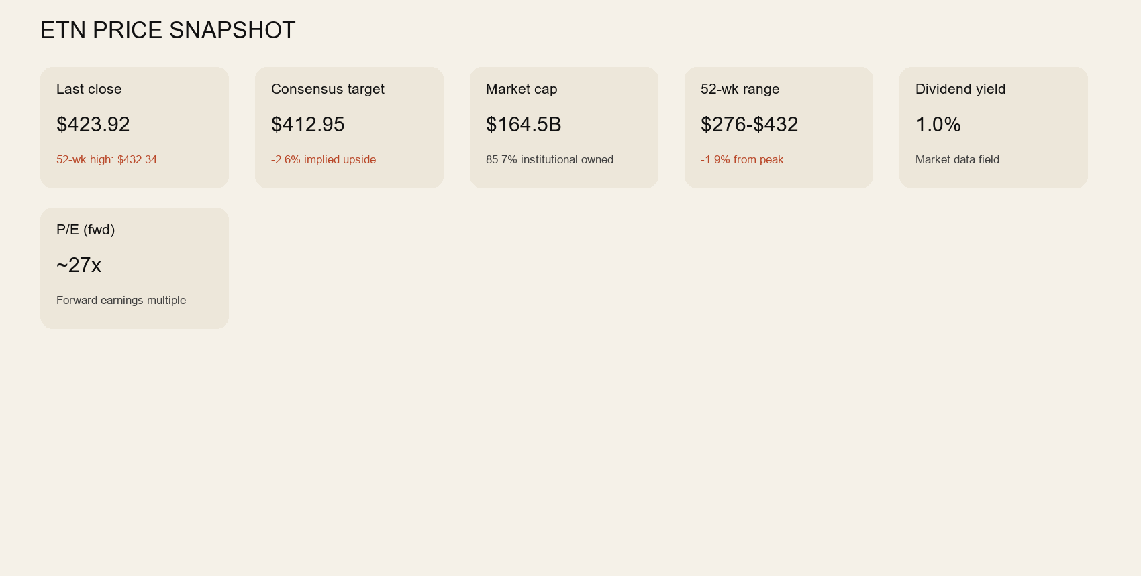

4. Historical Trend
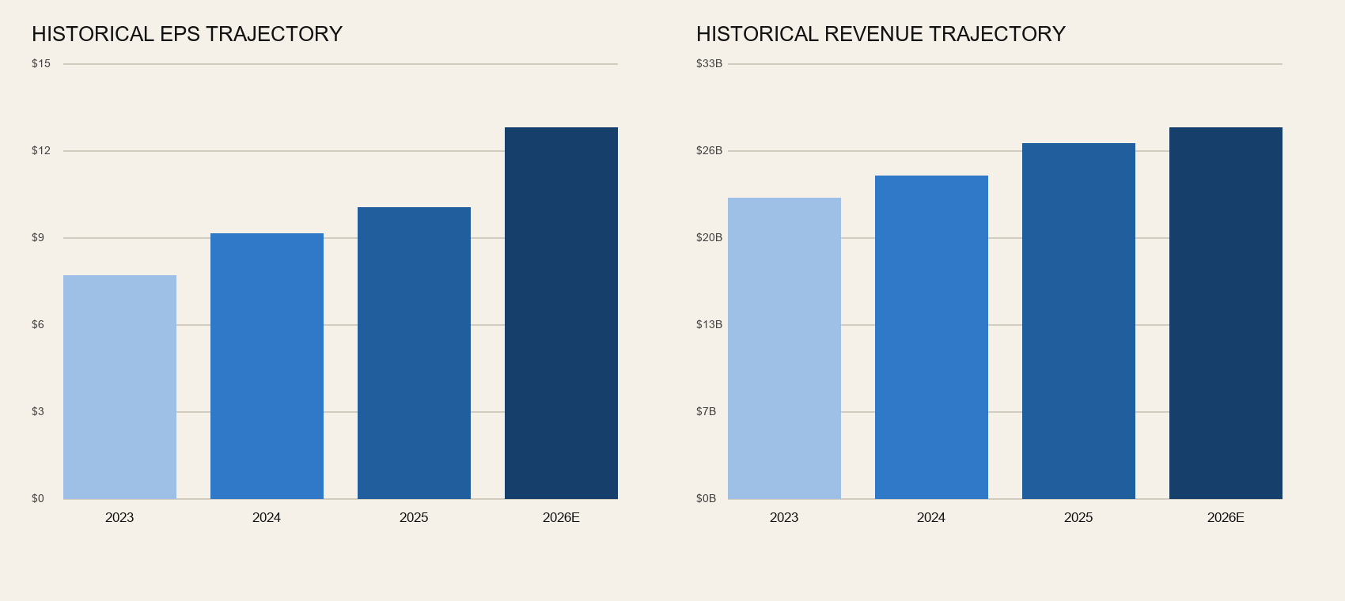

5. Valuation and Quality Metrics
Metric | Value
Revenue | $27.4B
Free cash flow | $2.6B
Operating cash flow | $4.5B
Trailing P/E | 40.5
Forward P/E | 27.4
Price / Sales | 5.99
Price / Book | 8.47
Profit margin | 14.9%
Operating margin | 20.0%
ROE | 21.5%
Current ratio | 1.32
Quick ratio | 0.74

6. Analyst Context
Metric | Value
Consensus target | $412.95
Median target | $419.00
Target range | $321.00 to $514.00
Rating | 1.7 - Buy
Recommendation | Buy
Analyst count | 28

7. Action View
Verdict: PULLBACK ONLY. Trend quality is strong, but price is pressing highs and current entry quality is poor. Wait for a disciplined pullback or a better-defined reset. A future upgrade would require better trend posture, improved entry quality, and a cleaner risk-defined setup than the market currently offers.

